Luke Pepin

2/11/2024

CSE-4300 Operating Systems – Assignment 2

1. Multithreaded Program

Code: data_to_kernel.c (included with submission)

Output:

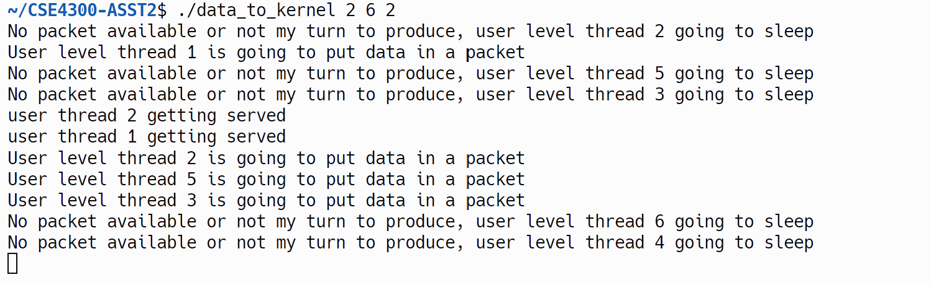

1. Consumer-Processor

Code: producer-consumer.c

Output: (Output goes: queue size 30->20->10)

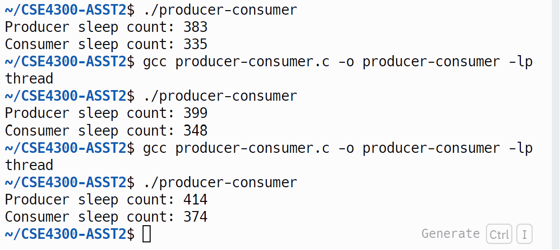

1. main.c was the name of the file that was changed.

Image: 